|  |
| --- |
| ATF PHOENIX FIELD DIVISION  PHOENIX IV (FIELD INTELLIGENCE GROUP) [phoenixfig@atf.gov](mailto:phoenixfig@atf.gov) |

**\*\*UNCLASSIFIED/LAW ENFORCEMENT SENSITIVE\*\***

***OFFICER SAFETY 6/07/11- 40mm Grenade Launchers***

**This bulletin serves to advise law enforcement to USE EXTREME CAUTION regarding the below items and to notify their appropriate Bomb Squad/EOD and ATF if the ordnance or launchers are encountered.** During the preceding months there have been numerous recoveries by Mexican authorities of M203 style 40 mm Grenade Launchers as well as a variety of 40mm high explosive (HE) ordnance, from criminal elements on or near the International Border with the United States. Mexican authorities have also had recoveries further into the interior of Mexico.

The M203’s that have been recovered are either military launchers that have been traced back to prior legal foreign military sales to Latin American countries that have been diverted for criminal use or improvised launchers that have been clandestinely manufactured from firearm components/parts. The M203 style 40mm Grenade Launcher is a rifle mounted launcher generally attached to M-16/M4 variant. There are also variants that are self contained, stand-alone launchers of various designs. Many of the clandestinely manufactured 40mm launchers are manufactured from commercially available, non-controlled 37mm flare launchers and 40 mm barrels that are machined to fit together. As of the date of this advisory, no recovered launchers have come directly from US military control.

When fired 40 mm grenades “arm” themselves by completing a specific amount of rotations over a distance of approximately 18 meters. Often the clandestinely manufactured launchers are improperly built; the launcher may fail to “arm” the 40 mm grenade, resulting in an unexploded round that may be

**\*\*UNCLASSIFIED/LAW ENFORCEMENT SENSITIVE\*\***

**\*\*UNCLASSIFIED/LAW ENFORCEMENT SENSITIVE\*\***

partially armed. Please **USE EXTREME CAUTION** if a round is found in the undetonated/ fired condition (lying on the ground etc…) and immediately contact the local Bomb Squad/EOD along with ATF.

The M203 40mm can fire a variety of ordnance including HE rounds designed to inflict personnel casualties. The M203 has a **maximum range of approximately (400 meters)** and requires approximately **(18 meters)** to arm a grenade when launched. **If engaged by someone with a launcher during law enforcement operations, seek immediate hard cover (ditch, concrete structure, overpass, rock structure, etc…)**

For Bomb Squad/EOD personnel most of the 40 mm grenades encountered have been US manufactured HE 40mm that have all been traced to legal foreign military sales programs or a South Korean direct copy of the US 40 mm with English markings.  **HE 40 mm rounds (explosive rounds) usually have gold colored projectiles but any 40 mm round should be considered an explosive until rendered safe by a Bomb Squad/EOD**. It is important that if possible, Bomb Squad/EOD personnel attempt to capture all the information about the grenade to include the LOT number in order to later help trace its origins.

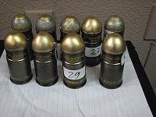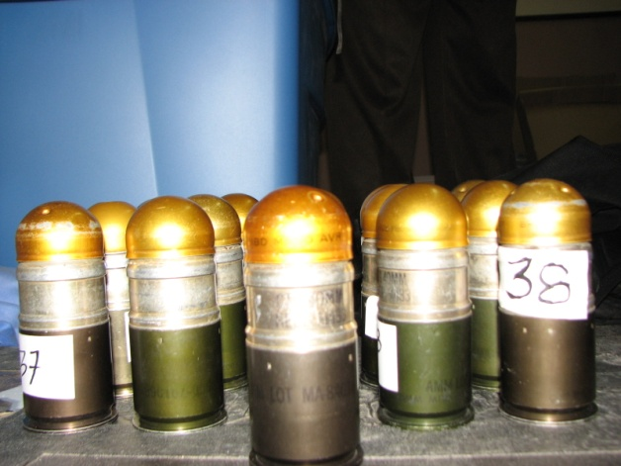

**South Korean 40mm Grenades US 40mm Grenades**

**\*\*UNCLASSIFIED/LAW ENFORCEMENT SENSITIVE\*\***

**\*\*UNCLASSIFIED/LAW ENFORCEMENT SENSITIVE\*\***

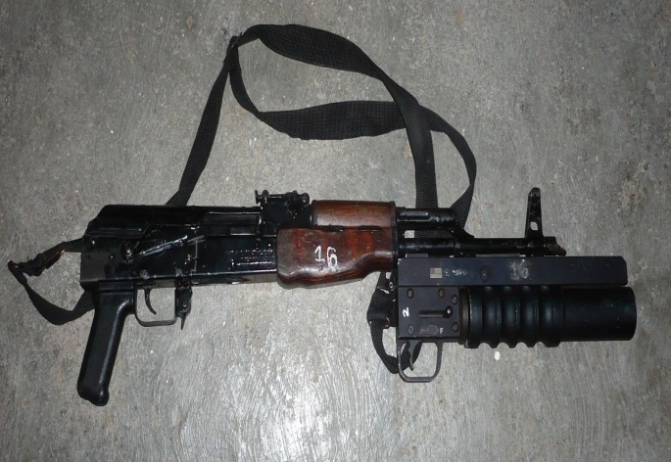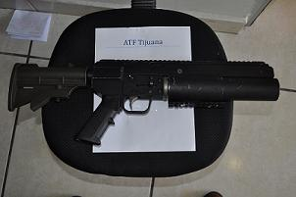

**AK-47 variant w/Improvised Launcher Improvised stand alone M203 Launcher**

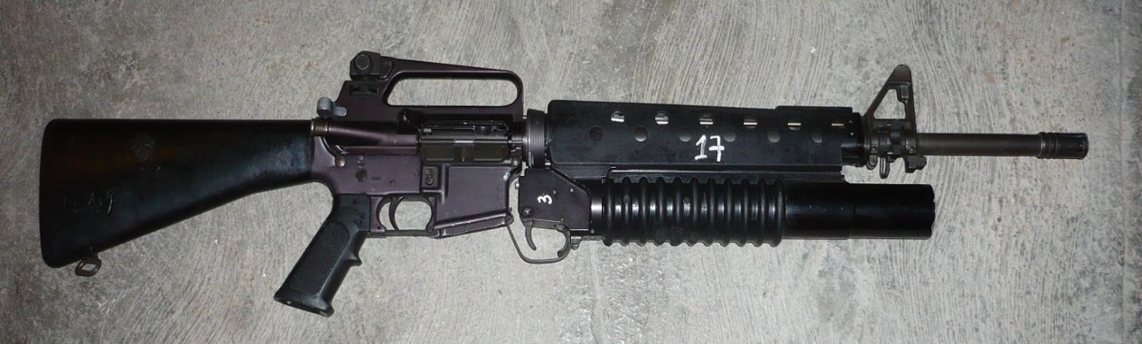

**M16 with attached M203 Launcher**

For any questions please contact the ATF Phoenix Field Division, Field Intelligence Group @ (602)776-5500 and/or email @ [phoenixfig@atf.gov](mailto:phoenixfig@atf.gov).

**All photographs taken by ATF in Mexico**

**\*\*UNCLASSIFIED/LAW ENFORCEMENT SENSITIVE\*\***